150 – 170 words

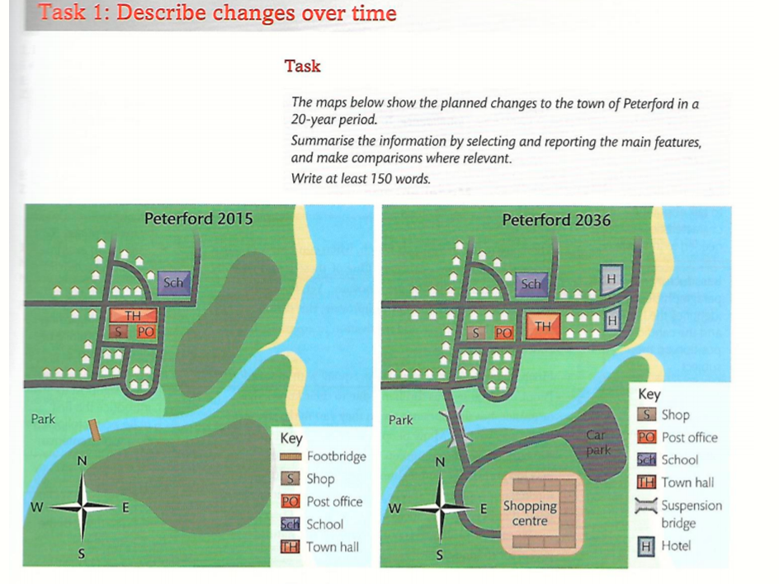

The given images represent the evolution of Peterford in the future 20 years.

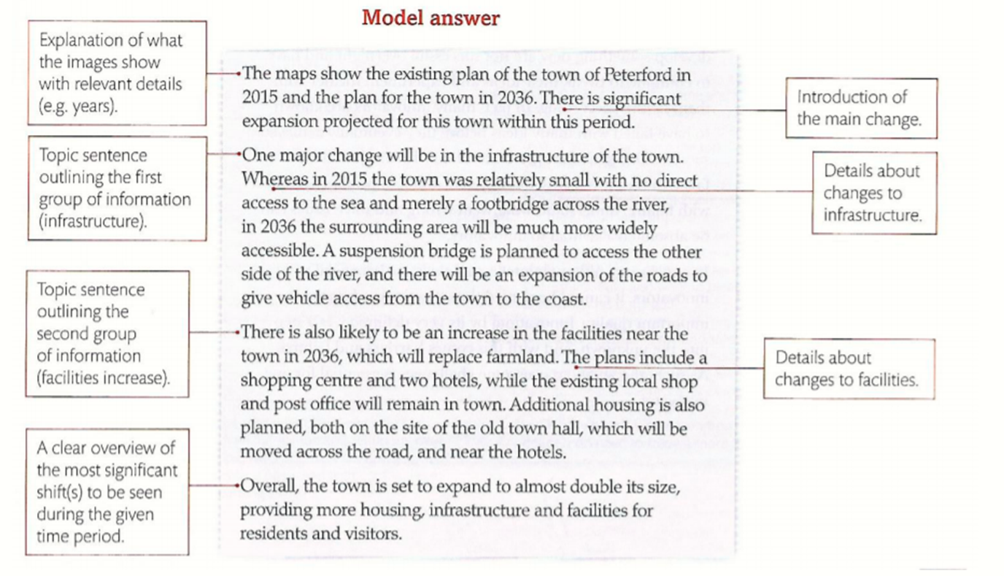

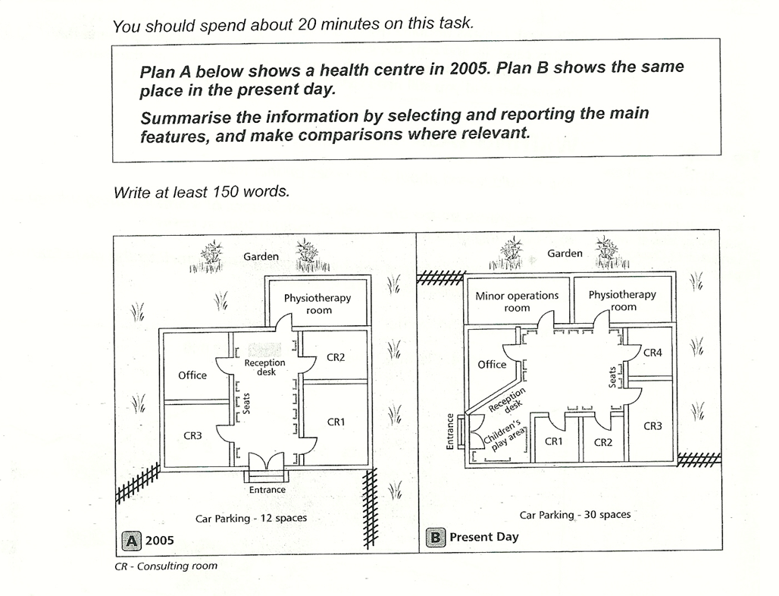

1. The reception area has been redeveloped. + The Car Parking has been expanded.
2. Minor operations room + Consulting rooms

Introduction

The two plans illustrate the developments that took place in the health centre between 2005 and the present day.

It is clear that the significant change has been made in terms of the enhancing facilities of the health centre.

Nowadays the health centre can provide minor surgical procedures with the addition of a new minor operations room in the northwest. Consulting rooms has exchanged places and there is a new one so now there is more space for taking patients. The car park has been extended to the west that has made the garden smaller. In 2005, there were 12 car-parking places. Nowadays there are spaces for 30 cars in the parking area.

Looking at the plans, we can see that now there is a completely new entrance that has been relocated from the southern part of the health centre to the southwestern side of the building. The location of the reception desk has become more convenient, exactly next to the entrance, unlike the previous reception desk situated further away from the doors. In the rear, the reception area has been modified by moving the seats and placing the children’s play area.